**Applcation work flow:**

This application is used to add new impacts and define beneficiaries for the added impacts.

Please find the below screens and their functionalities.

1. The below screen is the startup screen which contains menu for navigation between Impacts list view and Individual Impact record.

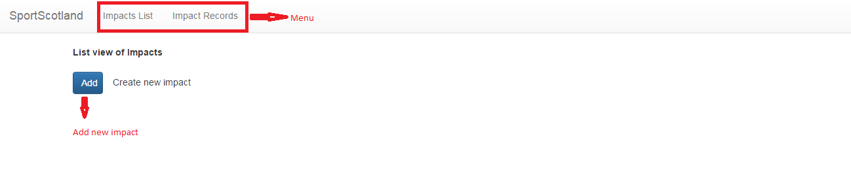

1. When the User clicks ‘add’ button then the below screen will be shown with option to provide Impact name and submit it.

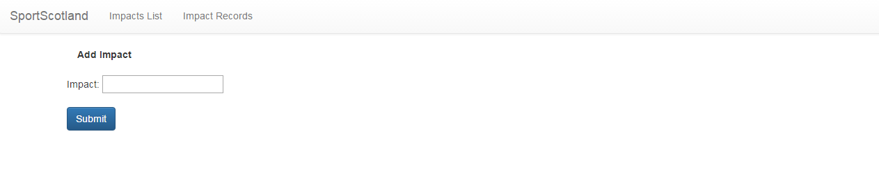

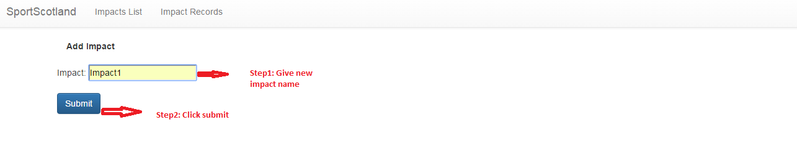

1. After the user clicks submit then List view screen will be shown with the added Impact and option to edit.

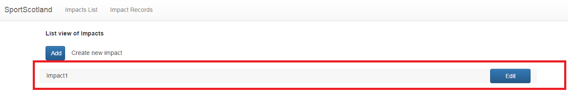

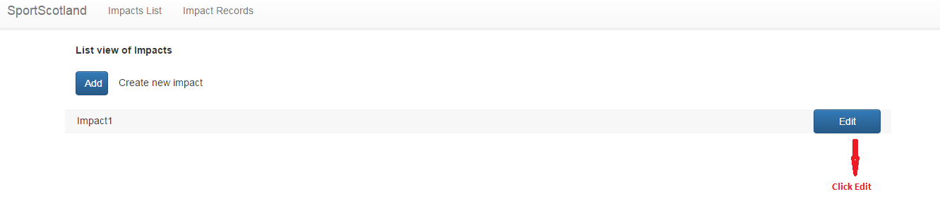

1. When ‘Edit’ button is clicked then Add Impact screen will show up with filled value.

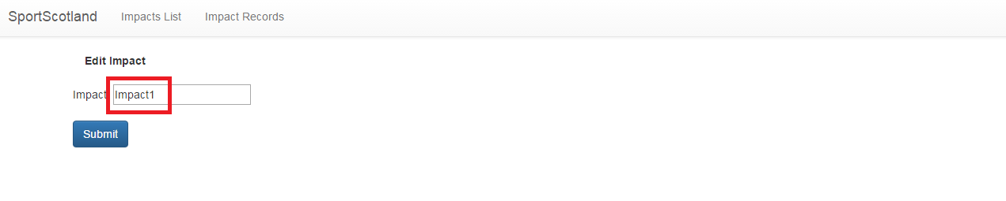

1. Now, the user can edit and again click Submit to save his changes.
2. Then, the user will be taken back to list view screen with changed value.

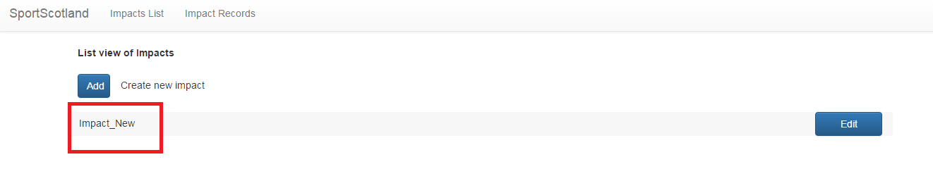

1. When the user clicks Impact Record menu then below screen will be displayed.

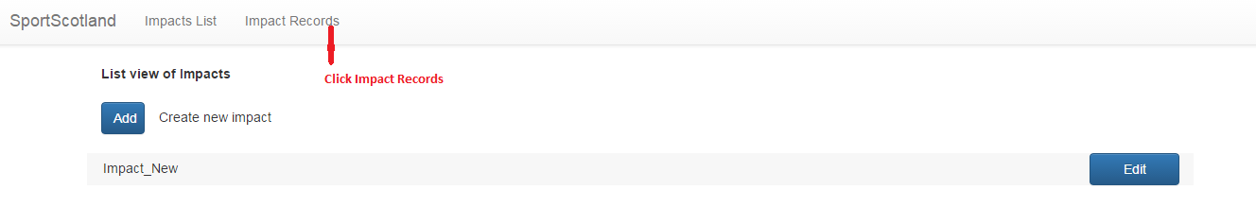

UserUser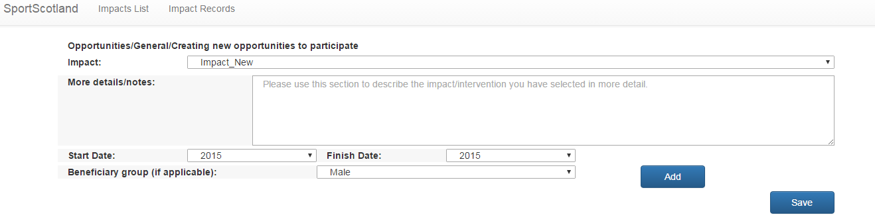

1. User can fill necessary details like below and Click save to submit the changes. Then the user will be taken back to List view screen as shown below. User can click menu again to view the changes.

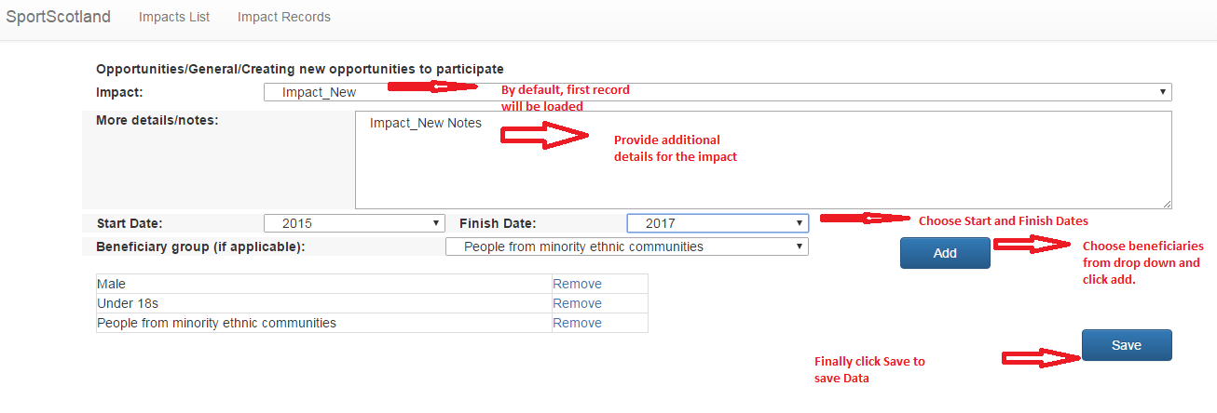

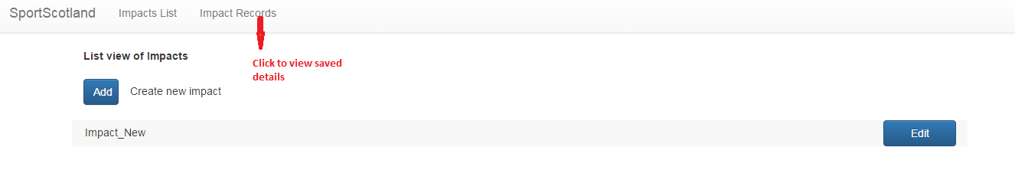

1. User can also add Impact in Impact record screen by choosing ‘Others’ from the Impact dropdown. Then, user has to provide Impact name and fill other details as shown.

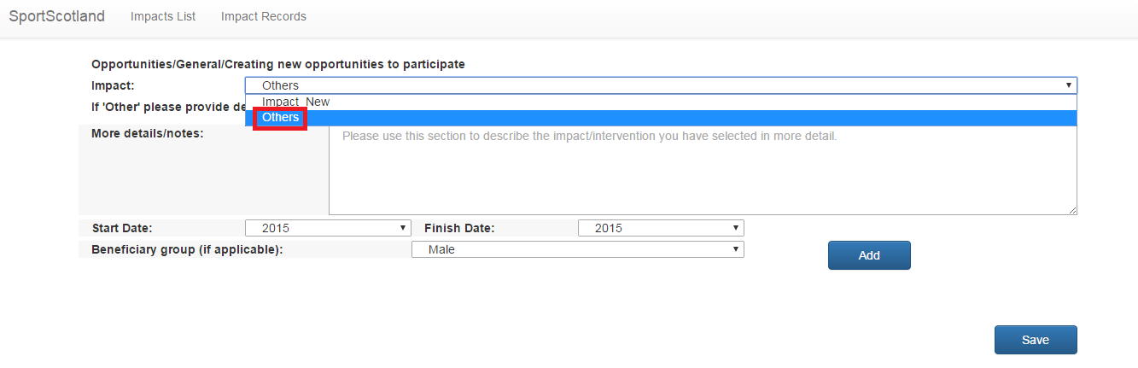

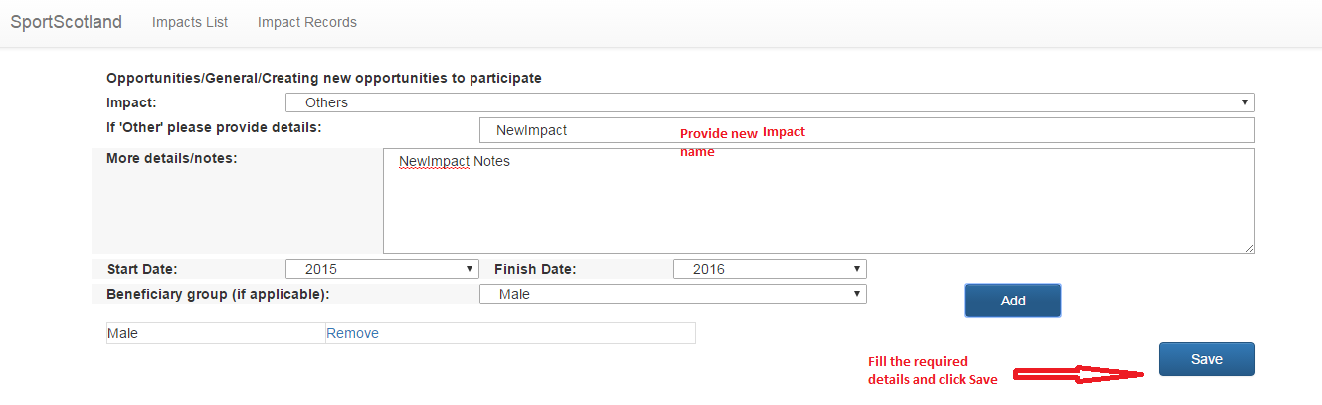

1. User can see the added Impact in the List view screen as shown below.

